Below is the electron configuration diagram for magnesium:

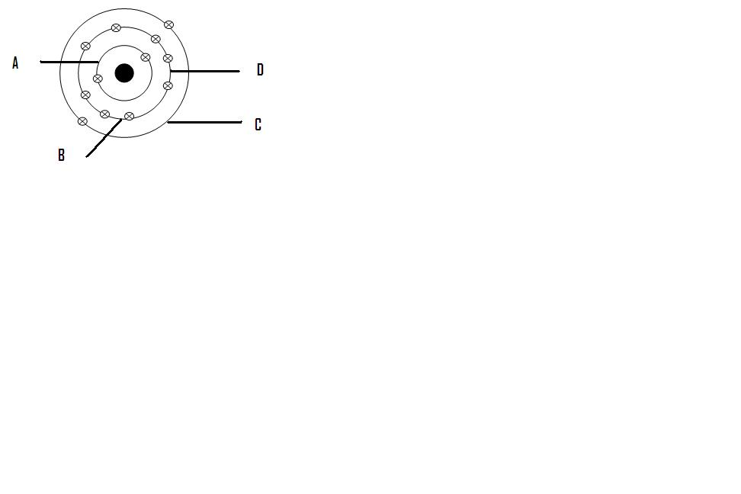

What is the valence configuration for Magnesium as shown in the above diagram?

1. Mg
2. Mg2+
3. Mg3+
4. Mg+

Which of these are ALL non-metals?

1. zinc, carbon, phosphorous
2. iron, nickel, aluminium
3. sulfur, iodine, argon
4. tin, gold, mercury

The symbol 26Fe56 represents information about the structure of a certain element. Which of the answers correctly lists the details described by the symbol?

(a) Element is IRON ; 26 protons, 56 neutrons, 26 electrons.

(b) Element is FLUORINE ; 26 protons, 30 neutrons, 0 electrons.

(c) Element is IRON; 26 protons, 30 neutrons, 26 electrons.

(d) Element is FLUORINE; 56 protons, 26 neutrons, 56 electrons.

What charge would an atom be if it

a. Loses electrons __________________________

b. Gains electrons __________________________